Nocarn Police Department
City of Burlington VT
MEDIA RELEASE
INCIDENT TYPE: | Second Degree Murder | DATE/TIME REPORTED: | April 13, 2026
INCIDENT NUMBER: | Champ-2447 | LOCATION: | Dick’s Sporting Goods, Williston, VT
INVESTIGATOR: | Noah Cacio & Max Carney | INVESTIGATOR CONTACT: | (802)-349-1714
AUTHOR: | Josh Allen | APPROVED BY: | Judge Tyrell Shavers

SUSPECT: | AGE: | SUSPECT ADDRESS:
Robert Gurfenstan | 36 | 316 Maple Street, Burlington, VT

SUSPECT DISPOSITION:
In Custody

NARRATIVE:
On April 13, 2026, the Nocarn Police Department responded to Dick’s Sporting Goods in Williston, Vermont following a reported homicide. The victim, Dan Stone, was found deceased at the scene. Investigation revealed that Stone and suspect Robert Gurfenstan, 36, of Burlington, Vermont had engaged in a prior confrontation through Instagram Direct Messages, during which the two arranged to meet at the Dick’s Sporting Goods location. Upon meeting, Gurfenstan allegedly killed Stone at that location. Following the incident, the victim’s family voluntarily surrendered Dan Stone’s mobile device to the Nocarn Police Department. Investigators Noah Cacio and Max Carney reviewed the device and discovered Instagram Direct Message threads between Stone and Gurfenstan, which led to the identification of Robert Gurfenstan as the primary suspect. Gurfenstan was subsequently taken into custody. The investigation is ongoing.

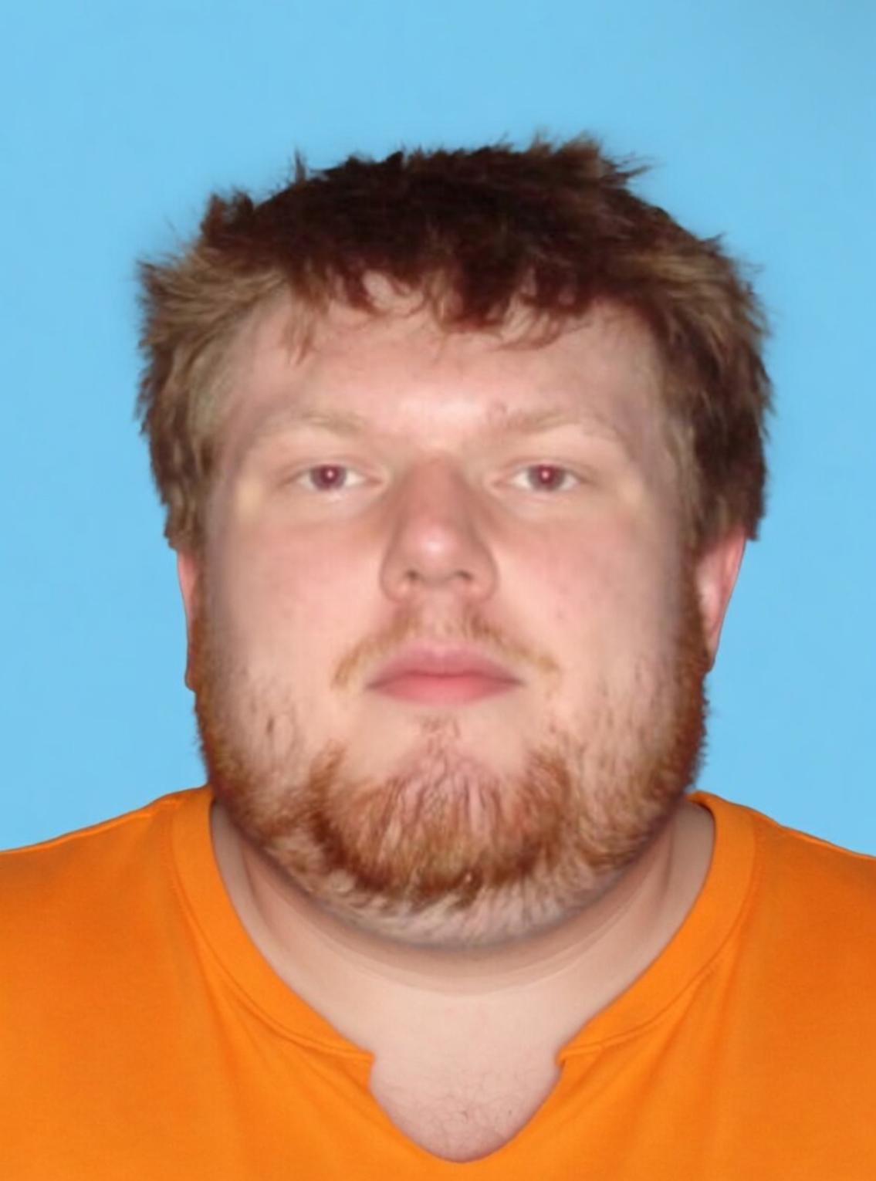

Anyone with information about this incident is asked to contact Nocarn Police Department at (802)-349-1714.
Information is preliminary and subject to change.
Nocarn Police Department • Burlington, VT 05401

